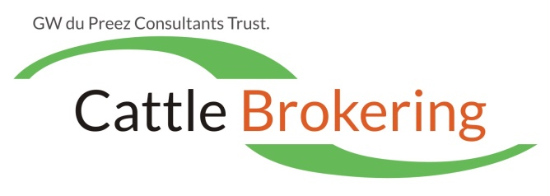
Buyers & Sellers Responsibilities

Below are normally the requirements when buyers and sellers work through a broker or agent.

Details normally needed by buyers and made available to the broker or agent before selection takes place, are as follows:

- CA / TB certificate issued by state Vet
- Milk buyer SCC report
- Veterinary protocol (inoculations done on whole herd)
- A Vet check for pregnancy status and any abnormalities must be done prior to payment by buyer.
- The animals to be in a suitable area to make selection easy for the buyer.

Cow / heifer details to be available before selection:

- Ear tag or freeze brand number
- Date of birth
- Lactation number
- Sire
- Dam’s sire
- Days in milk OR last calving date
- Service / AI sire
- Date of service / AI
- Due date

Procedures:

- After the Buyer selected the animals, he pays the seller directly or via the agent / broker as decided by the seller, before cattle are loaded.
- Buyer’s responsibility to organise transport, but most of the time the broker or agent arrange it on behalf of the buyer. Buyer pays transport costs to transporter.
- By law, the seller must have every animal branded with his registered mark if not a registered herd.
- The seller should mark animals with paint which are due to be dried off and also steam-ups.
- All animals must be dipped not longer than a day before loading.
- Animals in milk must be milked out before loading. Loading starts (usually) at 7 am or earlier.
- Seller is responsible for loading cattle and responsibility of cattle passes to buyer once the truck is off the farm.
- Buyer must make sure that the animals in transit are adequately ensured.
- After all requirements were met and the sale concluded, the animals are seen as sold voetstoots.

Ownership
The broker or agent need to be confident that the animals for sale are the seller’s exclusive and beneficial property, and that there is no reason in law why they can’t be sold.
Gerrie du Preez l +27(0)82 302 7883

